THURSDAY 30th AUGUST – 9.30am -2pm

Dear Parent and Caregivers. The P&C will be holding a Father’s Day Stall this Thursday from 9.30-2pm. All items will be sold at $5 dollars each.
All funds raised will go towards resources and equipment.
AB 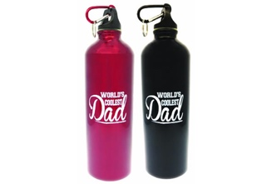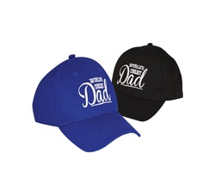C

D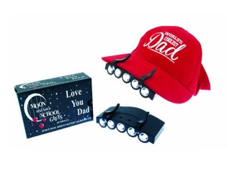 E 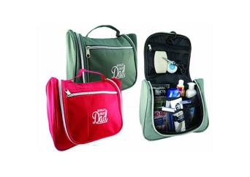 FGH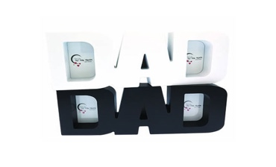I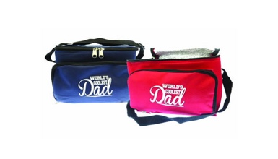
J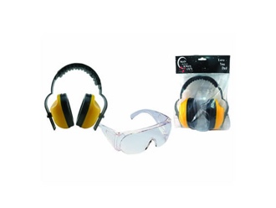 K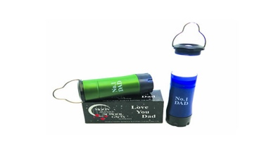 L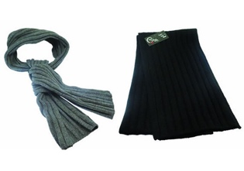M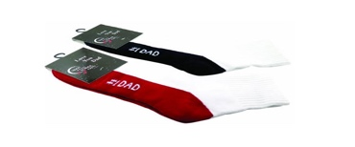N

KEY:
A Mug In Matching Box
B Aluminium Drink Bottle 750ml
C World’s Coolest Dad Hat
D Cap Light
E Travel/toilet Bag
F Love Dad Blocks
G Led Headlamp
H Dad Word Frame
I Cooler Bag
J Ear Muffs/safety Glasses Set
K Lantern And Torch Combo
L Woollen Scarf
M Sport Socks
N Stainless Steel Travel Mug

