[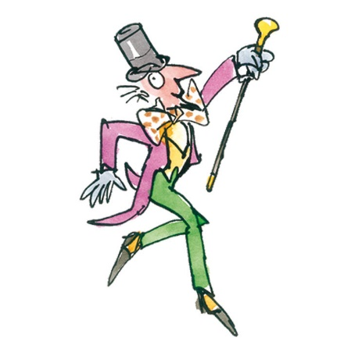](https://www.google.com.au/url?sa=i&rct=j&q=&esrc=s&source=imgres&cd=&cad=rja&uact=8&ved=2ahUKEwj1uenT6crcAhUCzLwKHVLRALwQjRx6BAgBEAU&url=https://breathenetwork.wordpress.com/2010/07/12/the-chocolate-factory-and-disconnecting-the-tv/&psig=AOvVaw2z1DL17GZK3mKkFcPHMxGA&ust=1533177567621214)[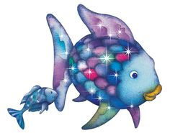](https://www.google.com.au/url?sa=i&rct=j&q=&esrc=s&source=imgres&cd=&cad=rja&uact=8&ved=2ahUKEwjc19TM6crcAhWO-mEKHfQFC8AQjRx6BAgBEAU&url=https://www.pinterest.com/pin/151715081166585933/&psig=AOvVaw0PVcruR051wSZPBdFEE08w&ust=1533177552511570)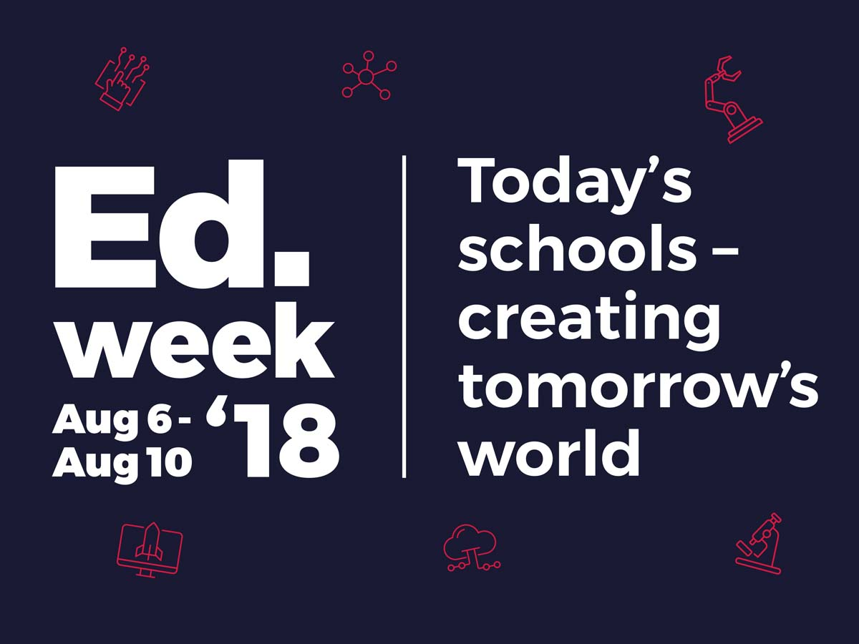**Education Week 2018**

[](https://www.google.com.au/url?sa=i&rct=j&q=&esrc=s&source=imgres&cd=&cad=rja&uact=8&ved=2ahUKEwifhtDh6crcAhWMAYgKHYXwCMUQjRx6BAgBEAU&url=https://www.popsugar.com/pets/Dr-Seuss-Animal-Characters-22005149&psig=AOvVaw0XrnkkLg7yB1qNk2lni7Mo&ust=1533177596490934)

[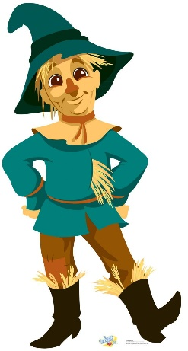](https://www.google.com.au/url?sa=i&rct=j&q=&esrc=s&source=imgres&cd=&cad=rja&uact=8&ved=2ahUKEwi2-Nij6srcAhUCU7wKHVDkCZUQjRx6BAgBEAU&url=https://www.pinterest.nz/pin/500603314821477178/&psig=AOvVaw0jsbderNs-dtO3GU1KgmuX&ust=1533177735029234)

During Education Week we will be seeking book donations for our school library. We are seeking

* simple early readers,
* picture books and
* simple chapter books,
* non fiction children’s books.

Please send them in a bag with a note in your child’s communication book.

On Thursday 9th August we will be holding a book parade as part of our Education Week events so we ask that students come to school dressed up as their favourite book character. All students will be part of the book parade for our parent and community visitors. If your child has a copy of the book that their character comes from, they may wish to bring this in on the day of the parade to share with their class. Book prizes will be awarded for the best dressed book characters in A Block, B Block, C Block, D Block and Demountables. We hope to see some fantastic book character costumes on this day!

Book Donations can be sent in any day

We are also having a student/sibling colouring in competition to be returned by Thursday 9th August.

|  |  |  |
| --- | --- | --- |
| **Monday 6th August** | **Thursday 9th August** | **Friday 10th August** |
| Georges River Environmental Education Centre Incursion for students | Book Character Parade  9:45am-10:10am  Picnic with Parents – students to bring their favourite book to share with their class  10:10am-10:45am  Morning tea for parents  10:45am-11:45am Zen Zone  Return Colouring in Competition with name and age of student/sibling | Education Week Assembly 9:15am  Book Parade Costume winners announced  Student/Sibling colouring in competition announced |

**Book Character Costume Ideas**

Where the Wild Things are

* Max
* Wild Thing

Peter Pan

* Peter
* Tinker Bell
* Captain Hook

Fairytale Characters

* Red Riding Hood
* The Big Bad Wolf
* Little pig
* Jack
* Giant
* Gingerbread Man
* Billy Goat Gruff
* Rapunzel
* Puss in Boots
* The Three bears
* Snow white
* Cinderella
* Wicked Witch
* Handsome Prince

Nursery Rhyme Character

* Humpty Dumpty
* Little Bo Peep
* Farmer in the Dell
* Baa Baa Black Sheep

Alice in Wonderland

* Alice
* White Rabbit
* Cheshire Cat
* Mad Hatter

Winnie the Pooh

* Winnie the Pooh
* Piglet
* Eeyor
* Tigger
* Roo

The Lion, the witch and the wardrobe

* Aslan
* Mr Tumnus
* The White Witch

The Very Hungry Caterpillar

* Caterpillar
* Butterfly

Charlotte’s Web

* Charlotte
* Templeton
* Wilbur
* Fern

Charlie and the Chocolate Factory

* Willy Wonka
* Augustus Gloop
* Veruca Salt
* Oompa-Loompa

Harry Potter

* Harry Potter
* Hermoine
* The Weasleys
* Dumbledore

Hairy McLary Series

* Hercules Morse
* Bottomley Potts
* Scarface Claw
* Muffin McLay
* Hairy McLary
* Pippi Longstocking
* Clifford the Big Red Dog
* Robin Hood
* Thomas the Tank Engine
* The Little Mermaid
* Wally (from Where’s Wally?)
* Captain Underpants
* Olivia the Pig
* Chicken Licken
* The Cat in the Hat
* The Rainbow Fish
* Angelina Ballerina
* Fantastic Mr Fox
* Winnie the Witch
* Harry the Dirty Dog
* Curious George
* Geronimo Stilton
* Mr Men/Little Miss….

