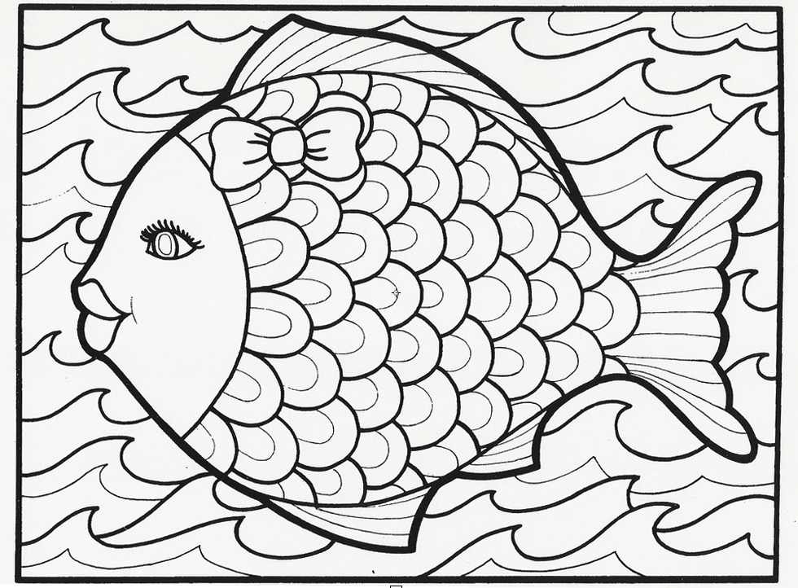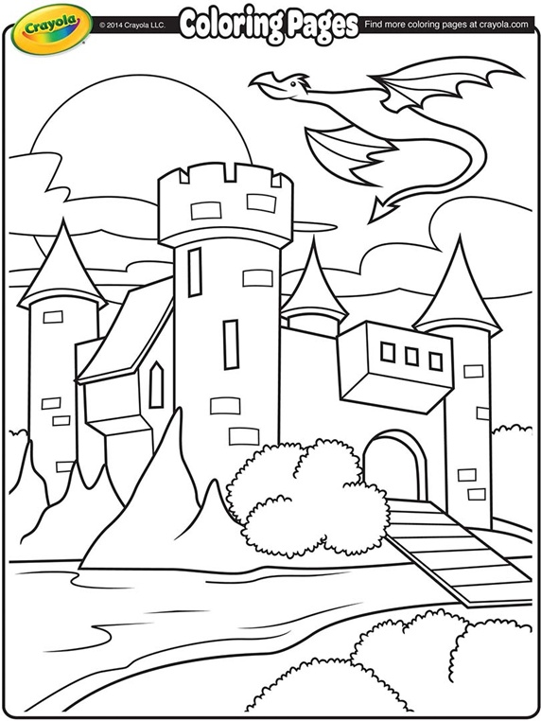

*student Name:*

*Sibling Name:*

*student Name:*

*Sibling Name:*

*student Name:*

*Sibling Name:*

*student Name:*

*Sibling Name:*