Emergency management
plan
Work Health and Safety Directorate
EMERGENCY MANAGEMENT PLAN
For
Broderick Gillawarna School (SSP)

Effective: March, 2009

Date of last review: 25/11/2016

Review date: 30/6/2017

The purpose of the emergency management plan is to ensure the health, safety and welfare of all staff, students and others at the workplace in the event of an emergency. In terms of the scope of the plan, the plan should address emergencies that can take place during activities away from the workplace (e.g. excursions or sporting events). Note that each excursion and sporting event requires a separate risk management process.

Document location

There are 4 copies of this manual – Electronic copy, School Principal, School Foyer, Staff Room.
Other copies are held by: Director, School Administrative Manager, 4 Assistant Principals and 1 Deputy Principal

  - Overview of emergency management plan
Purpose
To ensure the safety of staff, students and others in the event of an emergency and minimise the occurrence of injury and illness in the school through systematic hazard identification, risk assessment and control.
Objectives
To identify potential emergencies and implement elimination or control measures to prevent those emergencies, where possible
- To comply with WHS related legislation and directives or guidelines relating to health and safety.
- To identify potential emergencies and implement elimination or control measures to prevent those emergencies, where possible.
- To enable efficient preparation for emergencies through appropriate training of staff, testing of equipment and practice of evacuation drills.
- To provide staff and students with a clear understanding of how to respond effectively in the event of an emergency.
- To ensure the recovery of staff, students and the workplace after an emergency.

Scope of the emergency management plan
This emergency plan applies to all activities at the workplace and takes into account hazards that may occur within one kilometre of the school site. This includes:
- A number of major roads including: M5 motorway including on & off ramps; The River Rd & Beaconsfield Rd; Canterbury Rd, Stacey St, Milperra Rd.
- Bankstown airport
- East Hills train line with Padstow & Revesby stations
- 3 schools within 1 block of each other: Broderick Gillawarna School, Revesby Public School, St Luke’s Primary Catholic School, pedestrian & vehicle traffic
- Milperra industrial area
- Broderick Gillawarna School’s own major hazards:
- hydrotherapy pool resulting in possible drowning
- absconding from school grounds resulting in injury or death of students
- student mobility resulting in possible strains & back injuries
- student behaviour resulting in significant delay in successful evacuation procedures.

Description of the workplace (e.g. location, if a split or single site, no of students and staff)
This Special school has 93 students with moderate to severe intellectual disabilities, physical disabilities, autism & behaviour issues. It is located in Revesby in the Local Government Area of East Hills.

The school has approximately 43 staff consisting of the: Principal, 1 Deputy Principal, 4 Teaching Assistant Principals, 15 Classroom Teachers, 4 RFF teachers, a Senior Administrative Manager (SAM), 2 School Administrative Officers (SAO) 16 School Learning Support Officers (SLSO), a DGO and a General Assistant.

The school has three separate cleared areas used for play during breaks and evacuation drills. The basketball court is directly at the front of the school in Victoria St. The quadrangle is in the middle of the school and the sensory garden and pathway is located at the back of the school behind D Block and the swimming pool.

The Rainbow Swimming club uses the hydrotherapy pool on Thursday afternoon, Saturday and Sunday mornings.

Aqua Phys use the hydrotherapy pool on Monday and Wednesday afternoons and Friday mornings.

The Northcott Vacation program use D block, 2 classrooms and the playground area during each of the school holidays.

Share Care After School Care Program use C Block Practical Area, 1 classroom and the playground area 3.15pm – 6.15pm each school day.

Encore Program access the site on Wednesday from October to December (approximately 6 weeks)

Relationship with other plans (e.g. core rules, Chemical Safety in Schools, Local Government emergency plans)
See corporate management plans of: M5, Bankstown Airport, City Rail
This plan is subject to the actions and operations of emergency services on a larger scale in the event of a large scale emergency impacting on the community e.g. evacuation in the event of chemical spill.
School EMP should be read in conjunction with (before & after school care) plan. The plan located with school plan in WHS folder in principal’s office.

Roles and responsibilities
Emergency planning committee
Name | Position |  | Contact phone numbers
Karen McDonell | Principal |  | School: 9773 1255 Mobile: 0407 958 081
Aaron Gardener | Assistant Principal |  | 0412 361 700
Lydia Parke | R/Assistant Principal |  | 0438 258 742
David Grubb | General Assistant |  | 0418 632 628
Dennell Rooke | R/SAM
Wendy Stenning | School Learning Support Officer |  | 0407 363 145
Chief Wardens
Name |  | Position | Contact phone numbers
Karen McDonell |  | Principal | School: 9773 1255 Mobile: 0407 958 081
Aaron Gardener |  | Assistant Principal | 0414 361 700
Deputy Chief Wardens
Name | Position |  | Contact phone numbers
David Grubb | General Assistant |  | 0418 632 628
Lydia Parke | R/Assistant Principal |  | 0438 258 742
Wendy Stenning | School Learning Support Officer |  | 0407 363 145
Block Wardens
Name |  | Position | Contact phone numbers
Lydia Parke |  | B Block- R/Assistant Principal | 0438 258 742
Marina Pauschmann |  | D Block – R/Assistant Principal | 0425 291 843
Jacqueline Hamilton |  | C Block – A/Principal | 0412 361 700
Aaron Gardener |  | Demountables– A/Principal | 0414 361 700
First Aid Officer Communications Officer
Name | Position |  | Contact phone numbers
Danielle Sinclair | School Learning Support Office |  | 0432 592 917
Karen McEvoy | School Learning Support Office |  | 0412 782 790
Communications Officer
Name |  | Position | Contact phone numbers
Dennell Rooke |  | R/Senior Administrative Manager | School: 9773 1255

Process for notifying, alerting and reporting emergencies
Notifying emergencies e.g. process for notifying Chief Warden
All teachers and other staff are to ensure the principal is notified in the event of an emergency.
Alerting the workplace to emergencies e.g. preparing for evacuation, lockdown
The principal is to undertake appropriate action to alert the workplace of the emergency including commencement of evacuation procedures, where required. Where the principal is absent from the workplace, the Deputy Principal or nominated Assistant Principal is to undertake this responsibility. A repeated intermittent bell will ring indicating to staff to immediately leave their classrooms.
Reporting emergencies
- Contact emergency services on 000
- Contact Safety and Security for any school related criminal activity on 1300 363 778
- Report the emergency to - Director Public Schools NSW 94088900
- Contact the WHS Directorate immediately on 9707 6226 in the event of death, serious injury or dangerous occurrence in the workplace
- Report employee injuries to Incident Notification Hotline on 1800 811 523 immediately or as soon as reasonably practicable within 24 hours
- Report injuries to students and visitors to Incident Notification Hotline on 1800 811 523 immediately or as soon as reasonably practicable within 24 hours
- Follow the Department’s Incident Reporting Policy and Procedures for other necessary internal reporting (e.g. to Work Health and Safety Directorate for a WorkCover serious incident). To report an incident or injury please contact the Hotline on 1800 811 523.
Report incidents involving students and visitors on the Incident Notification Hotline 1800 811 523 or fax a Non-Employee Incident Notification Form immediately or as soon as reasonably practicable (but within 24 hrs) to the regional WHS Liaison Manager.
Identified evacuation assembly areas and evacuation routes
Assembly area one
School basketball court adjacent to Victoria St Revesby.
Assembly area two
Cul-de-sac Cnr Albert & Carrington St Revesby
Revesby Public School, Victoria St Revesby
Off-site assembly area (1 km from workplace)
The Mill Hotel, 189 Beaconsfield St, Milperra (9771 2722) (water, shelter & bathrooms available)
Johnstone Reserve, Cnr Bransgrove Rd & Queen St Revesby
(Refer to site plan, Part 2)

Location of offsite assembly area, e.g. emergency coordination centre and recovery premises (for major emergencies where it is necessary to evacuate school and normal assembly areas are not appropriate)
1. School administration area in A Block
2. Location to be confirmed by communications officer after consultation with chief warden
(Refer to site plan, Part 2)

Review dates
Last week of May each year
The emergency management plan will also be reviewed:
- following any emergency that impacts on the workplace
- following drills where the need for change is evident if there are major structural changes or changes that affect the plan to be implemented

Strategy for communicating the plan (e.g. training, newsletters, posters)
- Annual staff training (mandatory) Term 1 day 1 School Development Day
- Induction information for new staff
- Enrolment folder for new students
- One off copy of newly developed policy 06/16
- School foyer copy
- Staff room copy
- Casual Teacher folder
- Volunteer emergency information located in school foyer

Essential services on premises (e.g. location of hydrants, water main, etc)
Hydrants - none
Isolation taps for each block on street side

Location of water main  Also show on attached site plan | Water mains located – Albert St school gate
Location of gas main  Also show on attached site plan | Eastern cnr albert street
Location of electricity main  Also show on attached site plan | C block. Albert Street
Solar power main (where applicable) | B block main power.
Types of installed communication systems
Phone system in every classroom, block area, demountable and halls (access to OOO)
Main system located in Admin front office in A Block

1.2 Preparing for emergency

Risk management strategies for prevention or control of emergencies
Hazard | Risk associated with hazard | Key risk elimination or control measures |  | How often | Key staff responsible for implementation
Hydrotherapy pool | Drowning | Locked doors  High level of active supervision with staff ‘spotters’ on pool deck  Waiting students sit on chairs  Careful selection of student groups in pool & on pool deck  Parent consent forms warning of risks  Staff CPR & Emergency Care training  Non-slip mats, support bar  Pool hoist  Individual floatation device list on board in pool  Aust Swim accreditation for teacher in charge of class  1-1 supervision of students with seizures as per Epilepsy guidelines in separate swimming sessions. |  |  | Swimming teacher  WHS committee  Executive  Teachers
Absconding | Injury/Death | High level of active supervision during lunch play and at any time in playground for students who have a history of absconding  Exterior front and rear entry gates locked between 9 am and 2.45 pm. Supervision of gates between the hours of 8.30am – 9.00am and 2.45pm – 3.15pm.  During school hours, entry and exit only through front gate, monitored by office staff through electronic entry and exit or by key only. |  | Annual | Executive  Teachers  SLSOS
Lifting students | Back injuries & strained muscles | Use of:  - Hoist for students greater than 25kgs or students unable to consistently support their own weight  - 2 person lift for students less than 25kgs  - Height adjustable change tables  - Lift only from wheelchair/toilet level  - NEVER manually lift from floor  - Recommendations of student’s OT & Physio regarding lifting of students into/out of equipment  - Staff annually rotated in different classes with students with different levels of support needs.  - Multiple staff located in each block  - Clear signage specific to students in lifting locations by teachers each year in all learning areas affected  - T&D on use of hoists & height adjustable change tables  - Consideration of each lift by staff concerned with reference to Physio/OT recommendations  - Staff to lift using 123 planning of lift  - Students who refuse to stand are listed & strategies specified in individual student Behaviour Support Plans  - WHS agenda item in each Block meeting weekly  - Hazard notifications  - WHS meetings & inspections |  | Annually | WHS committee  Executive  Teachers  SLSOs
Fire | Burns, smoke inhalations, death | Regular evacuation drills  Worksite inspections  Workplace Buddy Inspection Checklist  Housekeeping throughout school to eliminate fire hazards  Control of debris around buildings  Regular fire extinguisher inspection  Training for staff in emergency planning  Fire Safety Statement |  | 1 per term  1 area per term  1 per year  Weekly at meetings  ongoing  6 months  Annually  Annually | Principal/WHS  Committee  All staff  WHS Committee  GA  Contractor  Principal/WHS Committee  Committee/e learning  Dell Tepic
Vehicle collision outside the school/  pedestrian accident | Staff and students injured | Information on pedestrian crossing outside school to students and parents.  Communication strategy for parents in newsletter  Ongoing consultation with RTA.  Installation of bollards and speed hump in Albert Street |  | Annual  2 per year  Regular  Once | Principal  Principal  Principal  RTA in 2015
Unauthorised  Intruders | Staff and students threatened by violent behaviour | Implement pass system for visitors.  Raise teacher and student awareness information  Locking of external entry points. |  | Review annually  Regular | Principal  Principal/All staff
Health Emergency | Staff, student or visitor at the workplace with sudden medical condition that may require an emergency response  Environmental risks that may trigger a health condition eg anaphylaxis | Ensure effective emergency first aid response plans are in place  Educate staff on how to respond to an emergency  Staff trained in anaphylaxis, CPR & e-emergency care  Risk management plans in place for anaphylaxis  (None identified students in 2016)  Epi pens available in 4 excursion first aid bags  Epi pen kept in a central location in A Block  Health care plans in place |  | Annual  4 evacuation annually  Annual  As per training schedule  18 months  Annual | Principal/First Aid Officer/Committee  Principal/WHS Committee  Principal/WHS Committee/All staff  First aid officer/WHS Committee  WHS Committee  All staff
Training against emergency management plan
Type of training |  |  | How often
Emergency Management Plan |  |  | SDD January annually
Anaphylaxis training face to face |  |  | Every 2 years
Anaphylaxis e-learning |  |  | Every year
E-emergency training |  |  | Every 3 years
CPR & Emergency Care training |  |  | Annually
Manual Handling |  |  | Annually
Aust Swim |  |  | Every 3 years (Individual staff refresher)

Frequency of emergency response drills
Type of emergency response drill | How often | Details (see school calendar)
Building evacuation (fire evacuation) | T 1,2 & 3 | T1 Full notice, T2 partial notice, T3 No notice
Lock down or lock out | Yearly | T4

Arrangements for disabled persons
Strategy | Person responsible for action
Staff to stay with class and assist students to evacuate | Teachers and SLSO
Level of assistance by individual students determined by teacher in consultation with therapists & parents | Teacher
Emergency services to be notified of disabled person’s whereabouts where necessary | Principal

First aid requirements
Requirement | Action completed
First aid officer appointed | Yes
First aid officer participates in emergency drills | Yes
Portable first aid kit available which contains a general use auto injector and asthma medication/spacer | Yes (located in A Block in SAM’s Office)

Communications during an emergency
Requirement | List form of communication (e.g. PA system, agreed alarm signal) | Responsibility for commencing and managing communications
Staff to advise principal of emergency | Ext: 101 Phone/runner | All staff
Notify emergency services 000 | Telephone  Contact office staff ext 105,110,112 | Communications Officer – Mary Loutas
Primary means of communication in the event of an emergency | Repeated intermittent ringing of the school bell.  Siren from megaphone  Telephones and loud speaker announcement | Communications Officer and office staff
Secondary or alternate means of communication | Assistant principals all sections of school (including use of megaphone) | Block Wardens
Lock down/Lock out | Anouncement over school wide speaker system followed by office staff calling each block area.  Block supervisors to call/confirm each class has locked down and call confirmation into office staff.  Office staff to call any off site personel to inform them to delay returning to the site and inform Principal once all blocks are confirmed secure. | Office Staff  Block Wardens  Office Staff

1.3 Response

The process for making decisions
Once an emergency is reported the Chief Warden will assess:
- What is the nature of the emergency?
- How is the emergency developing – getting closer/moving away?
- Which emergency services should be contacted – Police, Fire, Ambulance, State Emergency Services?
- The immediate response action required based on the initial assessment?
The Principal will then immediately initiate the necessary actions and responses – evacuation, lockout or lockdown.
Immediate response actions (actions will often take place at the same time)
- Implement emergency evacuation, lockdown or lockout procedures where required
- Ensure first aid is administered and medical treatment is provided as soon as possible
- Contact and liaise with relevant emergency services
- Secure area, remove people from the area and make it as safe as possible while maintaining personal safety
- Establish the facts: assess the situations, plan who to contact, who will make the contacts, what assistance is needed from Educational Services Offices, School Safety and Response Unit, WHS Directorate and the Media Unit
- Report incidents involving violence, weapons, illegal drugs or major criminal activity to the Schools Safety and Response Unit on 1300 363 778
- Incident involving malicious damage, break and enter, fire and security breaches to School Security on 1300 880 021
- Report work related injuries and incidents to the WHS Hotline on 1800 811 523
- Report incidents involving an identifiable WHS issue or hazard to the WHS Hotline
- Contact injured persons family
- Ensure telephones are not used for anything other than incident communications
- Report the emergency through the Department’s incident reporting procedures (serious incident report, employee incident report if required)
Vehicle control during emergency (e.g. keeping lane clear for emergency services, directing traffic to keep lane clear for emergency services)
Who: GA and Office staff as directed
How: Keeps driveway clear for emergency services using hand held ‘Stop’ sign and wearing fluorescent vest where time permits. Keep driveway clear for emergency service vehicles and direct emergency services to appropriate area or to Chief Warden. Prevent other vehicles entering the site during emergency.
When: From time of contact with emergency services and during emergency situation until all clear is given

Evacuation procedures (summary) – Full procedures included in Part 2
☐ | Principal decides on the need to evacuate, where possible in consultation with emergency services. Advise when to return to the school in consultation with emergency services.
☐ | Principal to ring emergency evacuation bell (Repeated intermittent ringing of the school bell)
☐ | Teachers to evacuate in an orderly manner with all members of their classes via the shortest and safest route to the centre of the basketball court (assembly area), unless advised of alternative
☐ | Evacuation assembly area is determined
☐ | Executive in charge of each block to check that all classrooms are clear and lock them where possible
☐ | Classes to line up and move to designated evacuation point in classes. When the whole school is assembled, classes will sit in their groups.
☐ | Electronic rolls marked and printed copy taken with classroom teacher
☐ | Office staff to evacuate when advised. SAM to take all sign in/out books to designated assembly point
☐ | Executive in charge of each block to check designated block and toilets
☐ | Principal to brief staff on emergency and await arrival of emergency services or take other appropriate action
 | Location of fire extinguishers (See attached floor plan)
 | Location of fire blankets (See attached floor plan)
 | Location of first aid kits are in first aid room. Office staff to take portable first aid kit with auto injector and asthma inhaler with all relevant information and needs in it. Located in A Block in front office
Note: Plans showing the identified evacuation assembly areas and evacuation routes must be posted in the workplace. Evacuation maps should clearly mark all exit routes and assembly areas relevant to each building and the location of all firefighting equipment. Maps are to be displayed prominently throughout the workplace.

Response procedures for specific emergencies
Response procedures are provided in Part 2 for the following emergencies:
- Evacuation and Fire procedures
- Death of a student
- Violence of a student
- Violent intruder – lockdown
- Drowning
- Bomb Threat

1.4 Recovery

Strategy and description (documents included in Part 2)
Counselling strategy EAPS, DGO, Principal

Emergency Contacts | Who
Police Station | 000 (Revesby Police - 8724 6099)
Ambulance | 000
Fire Brigade | 000 (Revesby Fire Station – 9772-1625)
Director | 9408 8900 Jan Green
School Safety and Response Hotline | 1300 363 778

Trauma counselling and description | Who
Student Counselling | Counsellors – Ann Hankins
Staff Counselling | EAPS
EAP providers are contracted to provide counselling for staff immediately following an emergency or other incident | Employee Assistance Program (EAP)  Davidson Trahaire Corpsych 1300 360 364

Return workplace to normal | Action
Staff & student assembly and attendance check | All accounted for – no action required  Advise chief warden and head of emergency services if anyone not accounted for
Consultation with emergency services to ensure clearance to re-enter site | Once all clear given – school resumes normal routine
Consultation with Director NSW Public Schools, WHS Directorate, Assets Unit | Once all clear given – school resumes normal routine

Media
All enquiries from the media should be referred immediately to the Department’s Media Unit on 9561 8501. The Media Unit will assist in managing enquiries from the media for the necessary period.

1.5 Fire Safety Statement

A Fire Safety Statement must be obtained at least annually, within 12 months of the original Fire Safety Certificate.

1.6 Working alone

To ensure staff safety, staff are allowed on site at the following times:
Term Time
For staff access, Broderick Gillawarna School is open during the school term between the hours of:
- 7.00am – 5.00pm (non-daylight saving months); and
- 7.00am – 5.30pm (daylight saving months)
Weekends and Holidays
For access outside the above term time hours, special approval to be on-site is to be sought from the Principal/Workplace Manager by completing a working alone form and getting it signed off by the principal.
PART 2: Evacuation procedures and other attachments

Evacuation and Fire procedures
An evacuation due to fire or other emergency is classified as a Serious Incident. The Department of Education and Communities must be informed, including the School Director and Safety and Security. A Serious Incident Report must be filed. The school will implement a support plan which may significantly vary the normal school routine;

- Report the emergency to the Principal for transmission to the outside authority and internal personnel.
- Emergency signal will be a repeated intermittent ringing of the school bell system and prolonged ringing of siren with announcement over the megaphone (which will be taken close to blocks if possible) of where to assemble. – Principal (or nominee)
- Teachers or SLSO in block to inform staff in toilets that there is an evacuation.
- Children to be taken from the school to the designated area as quickly as possible. Inform class teacher if assisting to move students from that class.
- Area 1: Front of school on Victoria Street (Basketball court).
- Area 2: Back of school Albert Street (corner of Carrington Rd)
- Off Site: Johnstone Reserve cnr Bransgrove Road and Queen Street
- Off Site: The Mill Hotel, 189 Beaconsfield St, Milperra (9771 2722) (water, shelter & bathrooms available)
- In an evacuation to an off-site assembly area the school buses should be used to assist transporting staff and students. In the case of a bomb threat school buses must not be used unless they are deemed to be safe
- All property should be left behind.
- Staff that are not on class at the time are to support the evacuation of students in B-block and D-block.
- Designated supervisor/teacher to check block toilets.
- Electronic copy of class roll accessed by executive via mobile device as needed.
- Office Data backup tapes & Staff/Student/Visitors Sign In/out book collected by School Admin Manager
- Assemble in class groups in designated area or safe area.
- Teachers to check that all pupils are accounted for (Check class roll, if needed.)
- Principal (with support of staff member to hold class photos) completes roll call.
- Teachers to report any absences and last known location to the Principal (or nominee)
- Do not return to any building until directed that it is safe.
- Arrangements may have to be made to send students home. Generally students will remain at the suitable location until normal closing time.
- Teachers and School Learning Support Officers will take responsibility for the evacuation of students with other staff assisting the closest group in need of assistance.
- Office staff to take first aid kit with Epipen and health care plans (Kit Only labelled Emergency use)

Death of Student
When the death of a student associated with the school occurs, it is classified as a Serious Incident. The Department of Education and Communities must be informed, including the School Director and Safety and Security. A Serious Incident Report must be filed. The school will implement a support plan which may significantly vary the normal school routine;

Procedures:
- Staff informed of the student death through established communication networks.
- Counsellor informed and organised to be available.
- Staff meeting organised as soon as possible after obtaining necessary details, and a student Grief Counselling plan is formalised and documented.
- Serious Incident Report sent to Bankstown/Glenfield Area Office.
- Student counselling team organised and timetabled if needed. This may include class visits and private individual counselling when necessary.
- Staff counselling if needed.
- Parents and the wider school community informed in writing and counselling organised as necessary.

Violence of a student
When a student seriously injures another student or staff member and the victim has to leave the school site to seek medical assistance AND the offending student is suspended;

Procedures:
- Immediate situation resolved
- Suspension procedure is implemented and Student Injury form completed
- Staff debriefing provided for injured staff if desired
- Staff Injury and Workers Compensation procedure implemented & Employee Assistance Program (DEC free & confidential counselling service for staff) information made available
- Bankstown/Glenfield Area Office advised using Serious Incident Report. Safety and Security to be contacted.
- Counsellor advised
- Revision of Behaviour Support Plan for student and further safety procedures devised (as part of Suspension meeting) and implemented
- Recorded in Student Injury database and Staff Injury database

Intruder – Lockdown
When there is an intruder into the school and it is required that a lockdown take place, it is classified as a serious incident. The Department of Education and Communities must be informed, including the School Director and the Safety and Security Hotline. A serious incident report must be filed.

Procedures:
- Announcement over school wide speaker system followed by office staff calling each block area.
- Office staff to call police if it is determined that the intruder is armed or considered dangerous or has the potential to harm students or staff
- Block supervisors to call/confirm each class has locked down and call confirmation into office staff.
- Office staff to call any off site personnel to inform them to delay returning to the site and inform Principal once all blocks are confirmed secure
- General Assistant to lock gates to bike track, sensory garden and front gates if possible
- All staff to ensure classroom door is locked, students are secure and blinds are pulled shut.
- Staff to await further instructions from office staff
- Office staff to take direction from emergency services or Principal

Drowning
When the drowning of a student occurs in the school pool this is classified as a serious incident. The Department of Education and Communities must be informed, including the School Director and Safety and Security. A serious incident Report must be filed. The school will implement a support plan which may significantly vary the normal school routine;

Procedures
- Supervising staff immediately remove drowning student from pool and assess the student and begin CPR procedures if required.
- School office staff and Principal to be notified immediately and they are to call for an ambulance on 000 and inform parents of the situation.
- School First Aid officer to be called to the pool.
- Staff to continue CPR on the student
- Other staff members to evacuate the other students from the pool back to the safety of their own block.
- Office Staff/Principal to direct ambulance to pool
- Staff member to accompany student to hospital in the ambulance until a family member arrives
- In the event that the student passes away, follow death of a student procedures.

Bomb Threat
When there is a bomb threat to the school, it is classified as a serious incident. The Department of Education and Communities must be informed, including the School Director and Safety and Security. A Serious Incident Report must be filed. The school will implement a support plan which may significantly vary the normal school routine;

Procedures:
- Report the emergency to the Principal for transmission to the outside authority and internal personnel.
- The school is to notify the Departments Safety and Response Unit of the bomb threat on 1300 363 778
- Person receiving call is to record as much detail as possible from the caller.
- If the threat relates to a bomb being present on the school site, the school should arrange immediate evacuation until such time as police attend and the site is deemed safe to return
- Emergency signal will be a repeated intermittent ringing of the school bell system and prolonged ringing of siren with announcement over the megaphone (which will be taken close to blocks if possible) of where to assemble. – Principal (or nominee)
- Teachers/SLSOs in blocks should inform staff in the toilets that there is an evacuation.
- School staff can contact the response unit on 1300 363 778 or the WHS Hotline 1800 811 523 for further advice if needed
- School should also implement other aspects of the school’s emergency management plan (E.g. notify the school director)
- Staff to be advised not to touch, tilt or tamper with a known or suspected explosive or unknown device and to carefully supervise students at this time.
- Children to be taken from the school to the designated area as quickly as possible. Inform class teacher if assisting to move students from that class.
- All bags and personal belongings are to be left behind.
- School buses are not to be used unless they are deemed to be safe
- Off Site: Johnstone Reserve cnr Bransgrove Road and Queen Street
- Off Site: The Mill Hotel, 189 Beaconsfield St, Milperra (9771 2722) (water, shelter & bathrooms available)
- The School is also to contact The Mill hotel to ensure that it is also clear of suspected devices and to ensure it is an appropriate location to evacuate to.
- All property should be left behind.
- Staff who are not on class at the time are to support the evacuation of students with highest needs (B-block and D-block)
- Designated supervisor/teacher to check block toilets.
- Electronic copy of class roll accessed by executive via mobile device as needed.
- Office Data backup tapes & Staff/Student/Visitors Sign In/out book collected by School Admin Manager
- Assemble in class groups in designated area or safe area.
- Teachers to check that all pupils are accounted for (Check class roll, if needed.)
- Principal (with support to hold class photos) completes roll call.
- Teachers to report any absences and last known location to the Principal (or nominee)
- Do not return to any building until directed that it is safe.
- Arrangements may have to be made to send students home. Generally students will remain at the suitable location until normal closing time.
- Teachers and School Learning Support Officers will take responsibility for the evacuation of students with other staff assisting the closest group in need of assistance.
- Office staff to take first aid kit with Epipen and health care plans (Kit Only labelled Emergency use)

Evacuation Plan with fire extinguishers

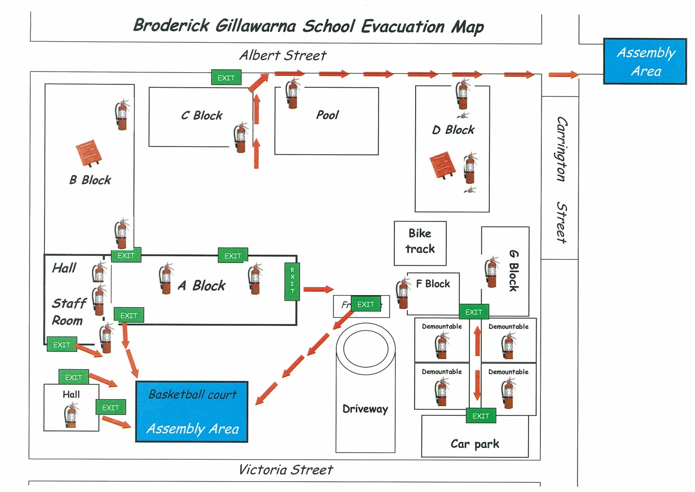

First Aid plan 2016 (2/6/2016)
Broderick Gillawarna School 2016 First Aid Plan
Assessment of first aid requirements | First aid plan (Controls) continued
Type of work performed  Teaching in the key learning areas.  Conducting and supervising playground activities.  Conducting office duties.  General maintenance and related duties.  Supervising school excursions.  Resources, equipment, machinery and other issues which may present hazards  Fixed equipment e.g. stoves and ovens, electric hoists, pool plant equipment, saws, gas heaters, hydrotherapy pool  Portable equipment e.g. lawn mowers, ladders, power tools, food technology tools, hoists and PE equipment.  Chemicals used in pool, cleaning.  Playground surfaces including uneven and wet.  Types of injury or illness likely to be sustained  Scratches, muscle strains, bruises, bites, abrasions, cuts, hair pulls and lacerations.  Asthma, anaphylaxis & epilepsy requiring an emergency response.  Number and distribution of people across the school  96 students  1 Principal and 1 Deputy Principal  19 teachers  16 School Learning Support Officers (SLSO)  2.85 office staff  1 general assistant  Size and layout of workplace  10 one storey buildings on 7 double building blocks  Location of school  School is located in a quiet residential street. Close to M5, River Rd, Milperra Rd  1km from a medical centre Revesby & Padstow)  3km from the nearest hospital (Bankstown).  First aid plan (Controls)  - One first aid officer  - 1x Backup first aid officer trained to take role in periods of absence.  - All holders of a current WorkCover approved first aid certificate (St Johns).  - Receive first aid allowance  - All school staff are trained annually at end of Term 4, in Emergency Care & CPR  - 7 staff members Aust swim trained  - WH&S committee representative of teachers, SLSO & management  - Phones in each classroom & other key rooms  Newly enrolled students  New students have information collected on a Profile & EduPro & OASIS. This information is then passed to the First Aid officer & Administrator of Medication  Response procedures  Staff should respond to the situation to render assistance. All staff have a responsibility in accordance with their duty of care to administer aid immediately as required, equal with their level of training and experience, for example, contacting an ambulance immediately where required or administering an adrenaline auto injector if a person is showing symptoms of anaphylaxis.  - The first aid officer is called immediately after an accident or incident has occurred using internal phone. Keep calm & limit number of staff involved.  - First Aid officer not to be called for minor bleeds, temperatures, diarrhoea. | - The first aid officer attends to the injured person. The first aid officer coordinates medical assistance and emergency services, as required.  - The first aid officer attends to a sick student & advises classroom teacher if student should go home. The supervising AP then determines course of action.  - The principal or SAM notifies the parent(s) (in the case of a student), next of kin or an emergency contact in the case of employees.  - The principal or injured employee notifies the WHS Hotline 1800 811 523 & follow the Department’s incident reporting procedures  - Often Health Care Plans exist for epilepsy and the procedures in the plan must be followed. All staff are to be made aware.  Sick bay and kit requirements and management  - One sick bay in A Block with notice outside of room.  - One first aid kit in each building (laundry areas where they exist)  - The main first aid kit at the school must have a general use adrenaline auto injector and an asthma inhaler  - A portable first aid kit for the executive in charge of playground duty.  - Provisions of general use injectors in additional identified first aid kits. All staff are aware of the location of kits indicated with a yellow tag  - Portable first aid kits to be taken on excursions as well as in buses  - A sign indicating where the sick bay, first aid officer and main first aid kit is located and where other first aid kits are kept is displayed in the staff room and in all classroom.  - Office staff takes kit during evacuations  - The first aid officer maintains the main first aid kit and its backup supplies.  - Used kit supplies should be noted by teacher to the first aid officer  First aid recording and reporting system  - Register of injuries is located in the main administrative office and is completed by the injured worker or visitor as soon as practicable.  - The administration of first aid is recorded in the record of first aid treatment located in the sick bay.  - The register of medications is maintained by First Aid Officer.  - All administrations of medication needs to have 2 witnesses  Communicating the first aid plan including infection control  - The plan is placed on the noticeboard in the staff room, pool, practical activities area in each block and in the main office & foyer.  - Information will be annually communicated to parents in the school newsletter  - It is communicated to all staff (including casuals), students and workplace visitors including induction information  Important contact numbers  Emergency 000  Medical Centre, Marco St Revesby 97739677  Bankstown Hospital 97228000  Poisons Information Centre 131 126  Bomb Threat Response Unit 1300 363 778  Confidentiality  Information regarding injuries is to be kept amongst staff who need to know.
Principal’s name:- Mrs Karen McDonell | Principal’ signature___________________________
Date:- 2/6/2016 | Timetable for monitoring and review for first aid The plan is to be reviewed annually with the input of First Aid officer, Executive in charge, staff and the WHS Committee.
1 km Evacuation plan to Johnstone Reserve (No shelter and toilet generally locked)

- In an evacuation to an off-site assembly area the school buses can and will be used to assist transporting staff and students. In the case of a bomb threat school buses must not be used as they may pose a risk.

2 km Evacuation plan to The Mill Hotel (Shelter, Water and Toilet)
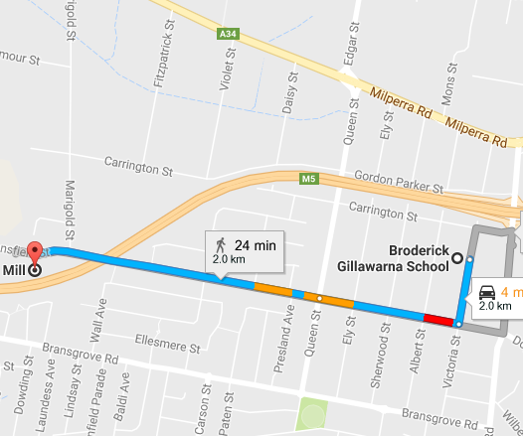

- In an evacuation to an off-site assembly area the school buses can and will be used to assist transporting staff and students. In the case of a bomb threat school buses must not be used as they may pose a risk.

After Hours Contacts

Name | Position | Contact No.
Karen McDonell | Principal | Mob:0407 958 081
Rebecca MacRae | Deputy Principal | Mob:0416 200 812
Marina Pauschmann | Assistant Principal | Mob 0425 291 843
Jacqueline Hamiton | Assistant Principal | Mob:0404 148 600
Sally Hawthorne | Assistant Principal | Mob:0410 685 341
Aaron Gardner | Assistant Principal | Mob:0412 361 700
Mary Loutas | Senior Administrative Manager | Mob:0405 512 450
Jan Green | Director | Mob:0411 165 112

Community User Contact Numbers
Company | Contact Person | Contact No.
Northcott | Armour Ncube or Ms Franklin | 4640 8702
Rainbow Club | Maddie Williamson | 0417 471 488
Share Care | Cindy Price | 8783 8078 or 8783 4888
Aqua Phys | Belinda Sidvak | 0417 683 372

Floor plans:
Block E (or A Block)
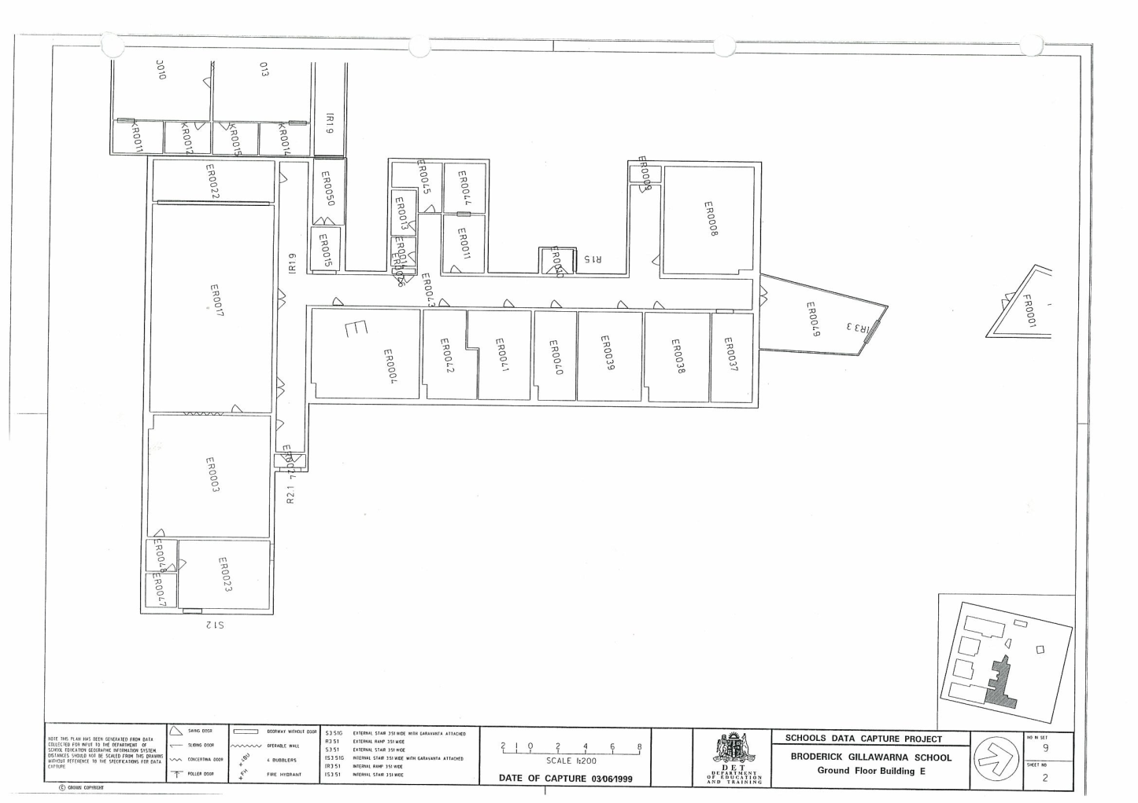
Block F

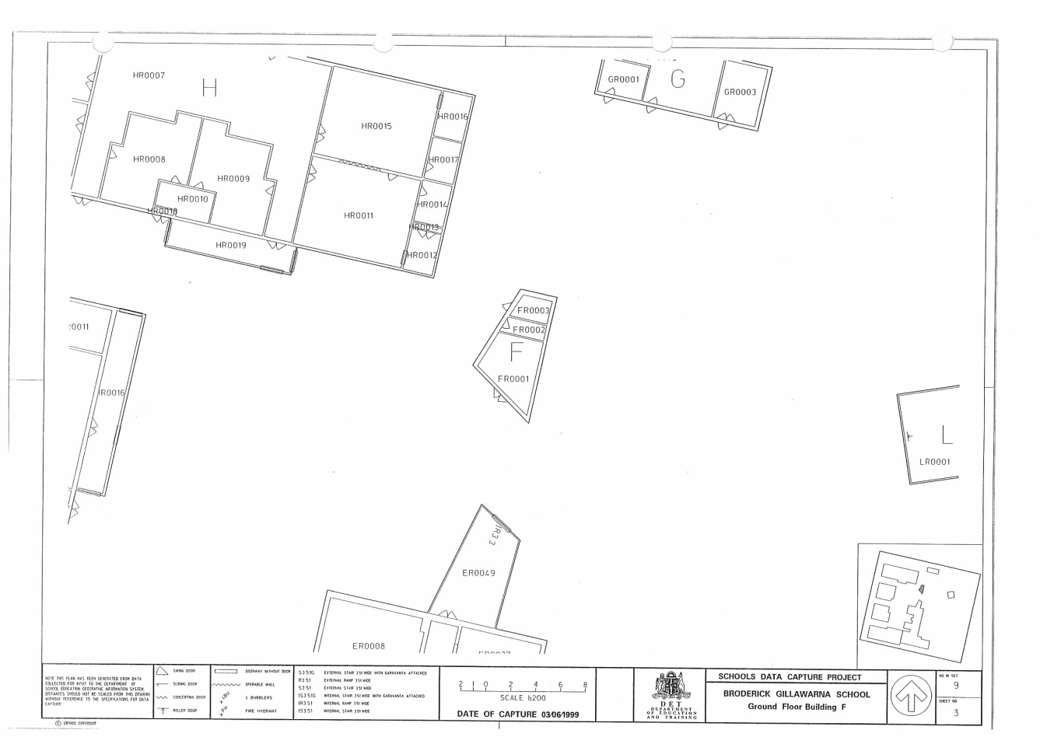

Block G
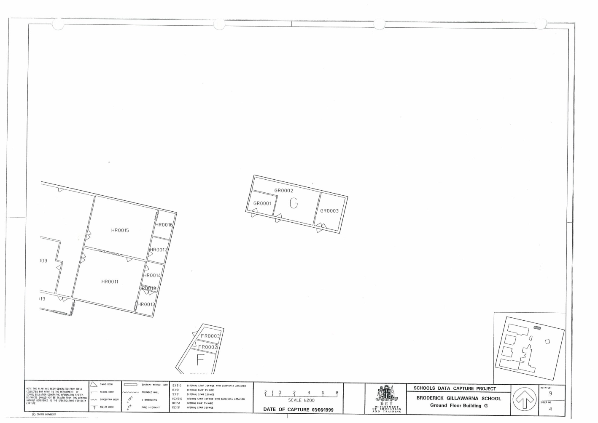
Block H (or D Block)

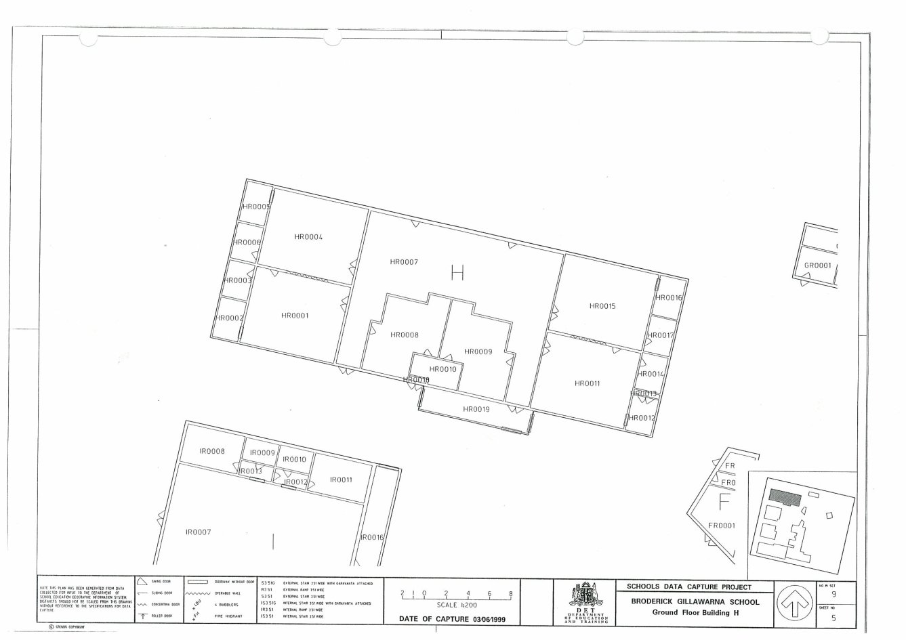

Block I

(Swimming/hydrotherapy pool)

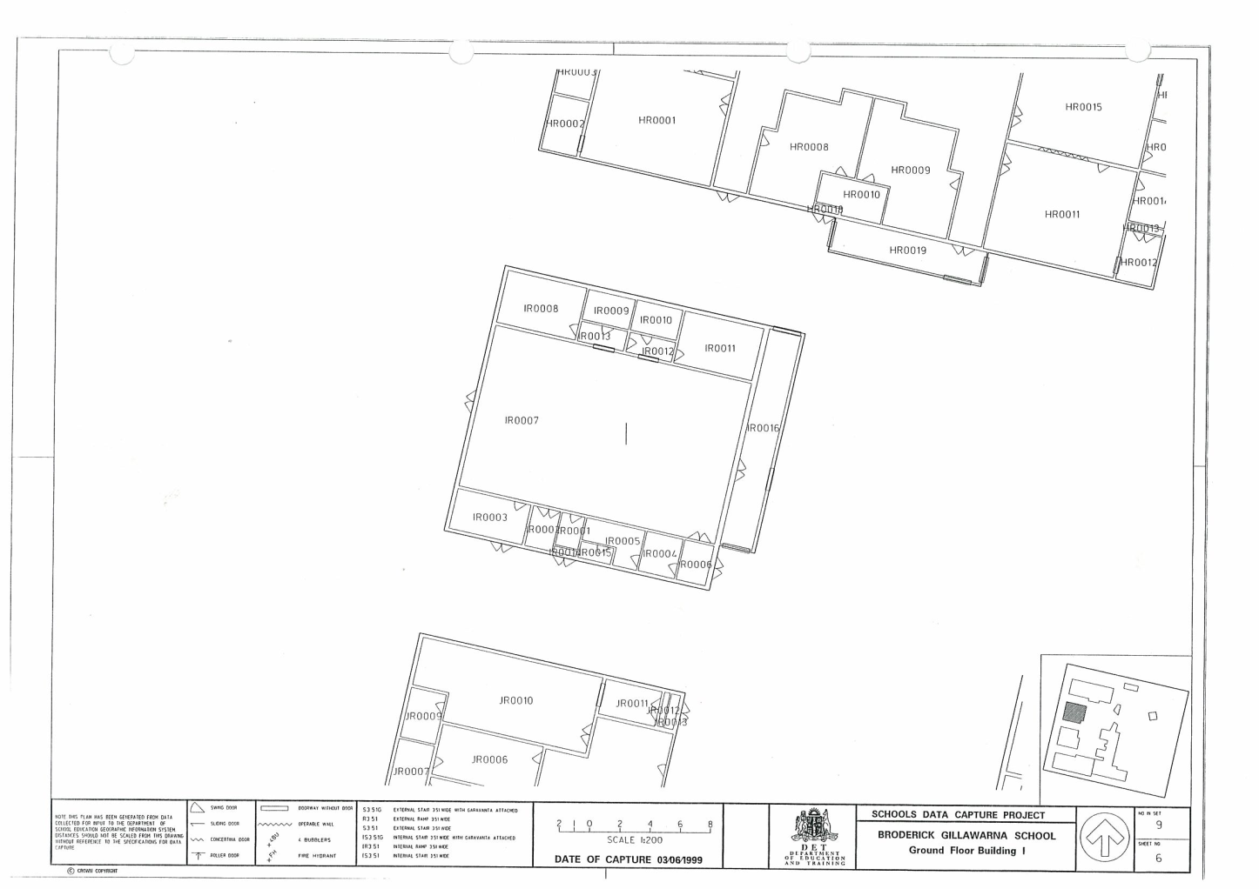

Block J (or C Block)

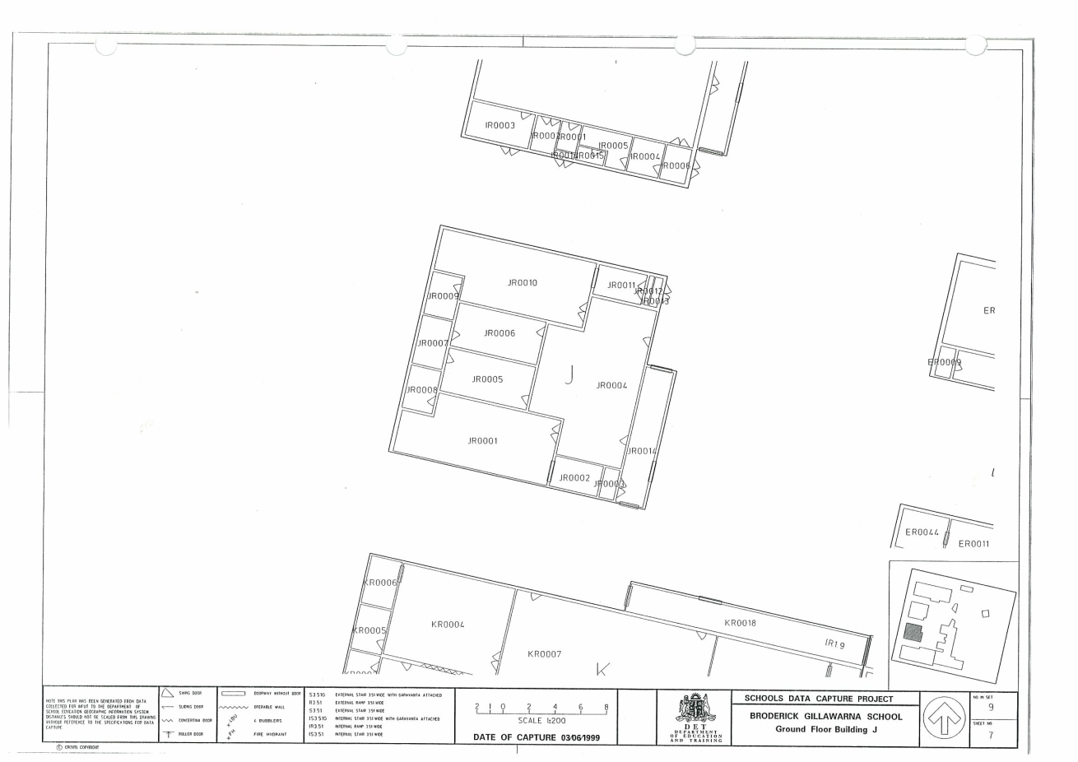
Block K (or B Block)

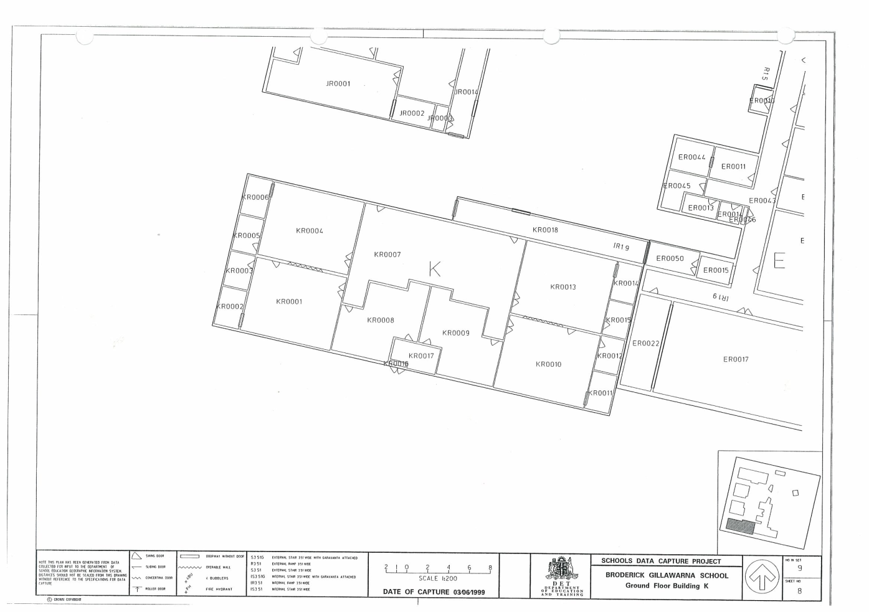

Demountables

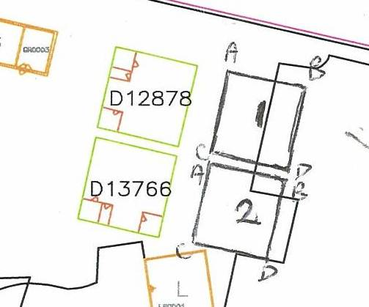

7 Core Hall (BER)

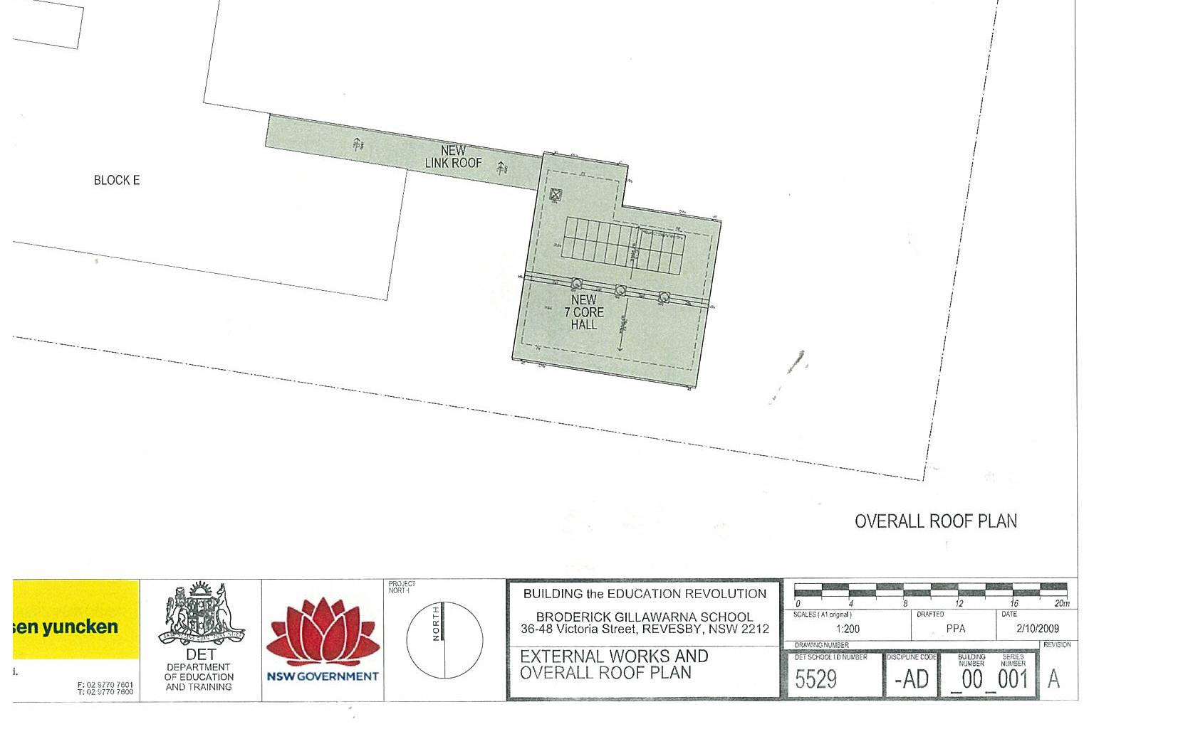

Checklist for documents to be included in Part 2
Documents attached: (Workplaces are to attach documents that relate to their Emergency Management Plan)
☒ | Evacuation procedures/Lockout procedures
☒ | First aid plan
☒ | Site plan (Note: each workplace will need to provide its own site plan: please contact Asset management if you require a copy.
☒ | Floor plans
☒ | Communication strategy (where there is additional information to section 1.2 above)
☒ | Specialist information – e.g. location of hydrants
☒ | After hours contacts
☒ | Other relevant information eg community users contact info

