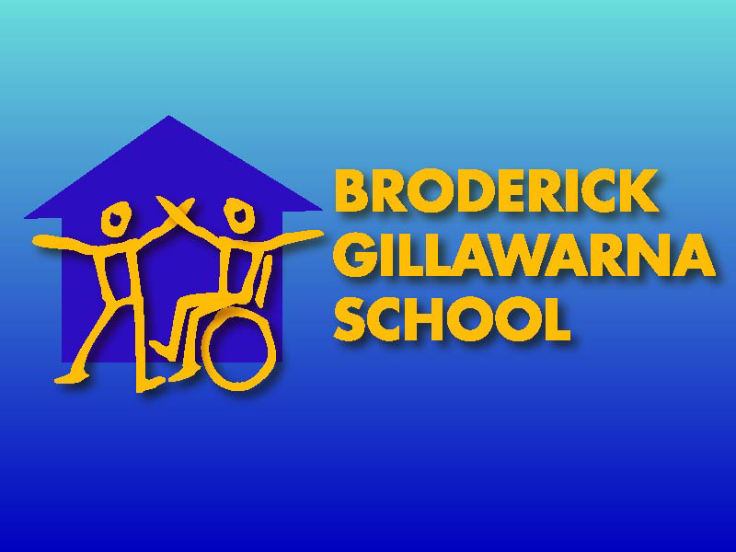

SCHOOL DISCIPLINE
POLICY

Revised Publication 6/08
Rewritten by:
E. Cameron
V. Azar
Original Publication: 8/98
Revised 11/03
Revised 5/07
Revised 07/11
Revised 07/13

Discussed and endorsed by Staff: 7/13
Discussed and endorsed by School Council:
Students informed of school rules associated with this plan: 7/13
Distribution to all staff: 7/13
Made available to parents in 3 languages Arabic, Vietnamese & Chinese:

Register of Updates to Policy
Date | Person writing change | Summary of changes | Page Numbers changed | Date of staff meeting re consultation of changes | Posting of Paper copy of latest policy changes
8/11 | K McDonell/S Hawthorne | Revised School Rules | All | 8/11
8/11 | K McDonell/ S Hawthorne | Reviewed in line with DET GUIDELINES/ Anti- bullying Plan | All | 8/11
7/13 | K McDonell | Learning and Support Team hierarcy | All | 7/13 | 7/13

STATEMENT OF PURPOSE

Broderick Gillawarna School caters for students with moderate to severe intellectual disabilities and designs together with parents, educational programs which meet the needs of students. Students generally have limited communication skills which may affect their ability to interact appropriately. The learning of communication and social skills is often a fundamental part of students’ educational programs.
Students may also have associated disabilities and medical issues which add to challenges faced by student’s e.g. physical disability, epilepsy, autism, and hearing and vision impairments. This may also affect student attendance.
The school has a school uniform which the parents are encouraged to have their children wear. There is flexibility to cater for individual needs of students e.g. medical.
Broderick Gillawarna School values students achieving the maximum participation in a caring, civil & just society. The school encourages successful learning by whole school team work, including parents and other key people in the students’ lives.
The school aims to provide strategies which promote discipline leading to self regulation and effective learning.
The school takes a positive view of discipline, emphasising the positive reinforcement of appropriate behaviours in preference to punishment for inappropriate behaviours. The school recognises that good discipline promotes effective learning through consistent and explicit teaching. Positive strategies that recognise and reinforce student achievement are by far the most useful. Some problematic behaviour's are complex and require considerable analysis and detailed support plans involving a multi-disciplinary team over a period of time. The school has developed an Anti-Bullying Plan in line with the guidelines set down by the Department of Education and Communities. Information within the plan is communicated to parents twice per year as part of the Personalised Learning Plan meetings. The plan makes adjustments for students with special needs regarding suspensions and definitions of bullying within the plan are specific to students with moderate to severe intellectual disabilities.

SCHOOL RULES
(in line with DEC Core Rules)

BE SAFE | - Stay with class  - Hygiene  - Hands to self  - Use equipment properly  - Walk in classrooms and blocks  - Listen for bell  - Cross road safely  - Control your emotions  - Self regulate behaviour

BE FRIENDLY | - Share  - Help  - Manners  - Personal space  - Eye contact

BE A LEARNER | - Listen  - Follow instructions  - Try  - Work  - Communicate  - Make choices  - Take care of belongings  - Independence  - Appropriate Volume

The above school rules have been designed to teach positive behaviour for the most frequent discipline area of need as identified by data. These rules are promoted across all curriculum areas, all teaching-environments and all staff.

STRATEGIES & PRACTICES TO PROMOTE POSITIVE STUDENT BEHAVIOUR INCLUDING SPECIFIC STRATEGIES TO MAINTAIN A CLIMATE OF RESPECT

The school:
- Provides curriculum to meet the needs of each student including communication, social and play skills: through explicit teaching
- Presents a repeated and consistent positive focused teaching to address student behaviour.
- Supports children in achieving success in learning.
- Has developed a small number of easily understood rules, which are fair, clear and consistently applied.
- Discusses with parents their role in promoting acceptable student behaviour in Personalised Learning Plan meetings.
- Provides appropriate training and development programs for staff.
- Provides support programs for students in the wider community.
- Provides programs that develop self regulation, self-evaluation, communication skills and peer support across the curriculum.
- Encourages student involvement in the formulation of class rules.
- Through the NSW Quality Teaching Framework students in all learning activities are taught to identify and solve problems, establish inference and compare; to lengthen engagement in learning. Students are also taught choice and self regulation within a socially supportive environment.
- Provides behaviour support strategies to parents and transport personnel to aid consistency.

STRATEGIES & PRACTICES DESIGNED TO RECOGNISE AND REINFORCE STUDENT ACHIEVEMENT

This school acknowledges the importance of emphasising positive reinforcement.
To promote positive student outcomes the school demonstrates:

- Specific praise
- Use of preferred and motivating activities of individual students
- Uses merit certificates, awards and other school based rewards.
- Use of newsletter to promote student achievements
- Encourages ongoing regular contact with parents.
- Fosters positive relationships with the local media to promote the school and students’ achievements.
- Models consistent and caring values and behaviour e.g. talks to, not at students.
- Adopts a practical approach to managing behaviour.
- Adopts across curriculum programming strategies.
- Collaborates with staff and other professionals (eg. School Learning Support Team and ISTB) to develop the best programs.
- Provides opportunity to succeed in all situations.
- Acknowledges the uniqueness of each individual and the special qualities.
- School wide positive reinforcement system linked to the school rules
- Reference to the school Anti-Bullying Plan when developing individual behaviour support plans and strategies.

STRATEGIES & PRACTICES TO MANAGE INAPPROPRIATE STUDENT BEHAVIOUR: BEHAVIOUR SUPPORT PLANS

Students exhibiting problematic behaviours will have an individual plan devised and written by the class teacher in conjunction with parents and other relevant professionals. To ensure a consistent approach, this plan will be presented at staff meetings and displayed in the classroom. All staff will be made aware of strategies for dealing with the problematic behaviours of individual students. Updates of these plans will be presented by teachers at staff meetings. The Effective Learning Team provides teachers with specific resources to support behaviour in the classroom, playground and the community. The School Learning Support Team meet weekly to review and update behaviour strategies for those students requiring additional support.
See:
- BGS Assessment, Programming & Reporting policy
- BGS School-wide framework for positive behaviour support decision making (below)
- Ant- Bullying policy 2010 (UPDATED 2011 AND 2012)
- School Learning Support Team proformas

Teachers are able to gain further information from their supervisors and school councillor at the school. Further external support is available through referral.

BGS School - wide framework for positive behaviour support decision making
1. Problematic Behaviour:
- Impedes ability for a student & other students to learn; staff to teach.
- Results in an all consuming focus on just that student
- May be an inappropriate form of communication
- Can be repetitive behaviour
- Provides an opportunity to learn a new skill/behaviour
- Often results in self hurt or hurt to others
- May include persistent property damage
- Results in limiting access to ordinary experiences, settings and services
- May result in suspension (refer to the Anti-Bullying Plan 2010)
2. Behaviour Support Plan:
      - Established when:
        - Normal behaviour management strategies aren’t working
        - Learning of other students is affected
        - Enough data & information is collected
        - School Learning Support Team identifies the need for formal intervention
      - Will need to be implemented until the behaviour has faded out

3. Process-What needs to be done:
Teacher | Teacher | Supervisor | Counsellor | Principal | SWS Region
Check w/ parents as to changes at home | ✓
Observe behaviour: what, when, where, whom | ✓ | ✓
Gather information. Previous plan? Current plan? Check with other staff | ✓ | ✓
Anecdotal data. | ✓
Write interim behaviour plan | ✓ | ✓ | ✓ | ✓
Collect data – ABC or expanded ABC | ✓ | ✓
Analyse data | ✓ | ✓
Establish behaviour support team |  | ✓ | ✓ | ✓ | ?
Complete 3 behaviour questionnaires with parent; school team (SLSO, Counsellor, Supervisor, Principal) | ✓ | ✓ | ✓ | ✓
Determine behaviour function | ✓ | ✓ | ✓ | ✓
Write behaviour support plan & parents sign off | ✓ | ✓ | ✓ | ✓ | ✓
Implement plan | ✓ | ✓
Review data & plan | ✓ | ✓
If no reduction in behaviour broaden team (DADHC psychologist; ISTB) | ✓ | ✓ | ✓ | ✓ | ✓
Review plan with all staff | ✓

4. Variables affecting order of process
- Frequency & force of behaviour may result in earlier involvement of school team members and reference to the Anti-Bullying Plan 2010
- Knowledge (thus experience) of needed teaching strategies by teacher (e.g. Prompt Hierarchy – too much physical assistance; Appropriate & quality of curriculum & strategies to engage students)
- Minor behaviours may be resolved & not need the completion of the whole process.

5. Whole school involvement:
- “Ownership” of all students by all staff
- Essential to the success of a behaviour plan is consistent implementation by all staff of determined strategies
- Immediate response to incidents by team members when required
SUPPORTING THE DEVELOPMENT OF APPROPRIATE BEHAVIOUR FLOWCHART

Define problem behaviour:
- Informal observation (anecdotal information) T
- Gather previous information (behaviour plan & data) T
- Consult previous teachers of student T, C, S
- Check with parents re simple explanation T, P

Isolated incidents
for extreme problematic behaviour
T, S or Pr
Support team codes:
T=Teacher
SLSO=School Learning Support Officer
C=colleagues
P= Parent
SC=School Counsellor
S=Supervisor
Pr=Principal
SWS=Regional staff (ISTB, DPC, Student Services)

Interim emergency plan
for extreme problematic behaviour
T, C, Pr, SC
Data collection:
- Collect detailed data using expanded ABC Stay with class
- Hygiene
- Hands to self
- Use equipment properly
- Walk in classrooms and blocks
- Listen for bell
- Cross road safely
- Control your emotions
- Self regulate behaviour
data sheet (school intranet) T, TAS, P
Analyse data T, S

Behaviour Support team:
5. Establish behaviour support team T, SLSO, P, C, Pr, SC
6. Analyse data T, S

Behaviour Support Plan:
- Complete 3 questionnaires (La Vigna, MAS, Problematic B. Questionnaire) T, SLSO, C, Pr, SC
- Determine Function of behaviour T, C, Pr
- Write Behaviour Support Plan (EduPro) T, Pr, SC
- Discuss with parents T, SLSO, C, Pr
- Parent signs off Plan T, P
- Implement T, SLSO, P
Review & monitor:
13. Monitor using continuous (usually frequency) data collection onto Excel in student electronic folder T
- Regularly review with reference to data T, S
15. Review data in PLP meeting T, SLSO, C, Pr
- If no reduction of behaviour, involvement of ADHC case worker & psychologist, Specialist Doctor SC, Pr
- A risk assessment may be necessary to determine risks to safety of students & staff (see BGS intranet)
- A crisis Management plan may be necessary should be behaviour become extreme. staff (see BGS intranet)

Suspension for serious inappropriate behaviour to other students and staff, can occur at any stage in the above process, depending on the severity of the incident.

STRATEGIES FOR DEALING WITH UNACCEPTABLE BEHAVIOUR

Due to the diverse population of this school it is necessary to have consistent support strategies that are age appropriate and consider the wide range of student abilities. The school has a range of strategies to deal with inappropriate behaviour. Intervention strategies used will be the least intrusive and least restrictive as possible. All should include augmentative communication systems as identified in the students program. Furthermore all strategies should be positively focused and be akin to the values and principles taught in PART training.
Strategies could include:
- Instructions, prompting, cues, redirection,
- Warnings
- Time out for short periods within sight of staff. In conjunction with existing behaviour support plans.(parent to be advised of ‘time out’ as a behaviour strategy within the plan)
- Withdrawal of privileges.
- Suspension as a last resort in line with Departmental policy and procedures.

UPDATE OF POLICY:
5 years or less, depending on the need

SUPPORTING DEPARTMENTAL DOCUMENTATION

DET Policies considered and incorporated into this policy includes:
- PD/2002/0052/V001 Student Welfare, Good Discipline & Effective Learning: Student Welfare Policy
- DET Student Attendance in Government Schools: Procedures (2013)
- DN/06/00154 Core Rules for Students in NSW Public Schools
- PD/2004/0025/V001 DET School Uniform Policy
- DET Suspension & Expulsion of School Students (2009)
- PD/2005/0131V001 DET Values in NSW Public Schools
- NSW Quality Teaching Framework

Broderick Gillawarna School Policies:
- Assessment, Programming & Reporting Policy
- Staff Development & Support Policy
- Anti-Bullying policy 2010

Broderick Gillawarna School Data:
- Student injury data (2010-2012)
- Student suspension data (2010-2012)
- Priority social skills survey (from the Effective Learning Team 2009-2011)
- Student outcome data (2010-2012)
- Teacher meeting discussion / evaluation (2010-2012)
- Annual 2010 parent and staff surveys on behaviour

ACTION RESULTING FROM POLICY REVIEW

- Develop a School Uniform Policy esp. hats & play & consequences & rewards → 2009
- Review by staff of Staff Development & Support Policy → 2009
- Review of Anti-Bullying Plan 2011 (Effective Learning Team)
- Review of student information and handover Term 1 of each year in conjunction with the School Learning Support Team
- Review of school rules to include scripted language and concepts



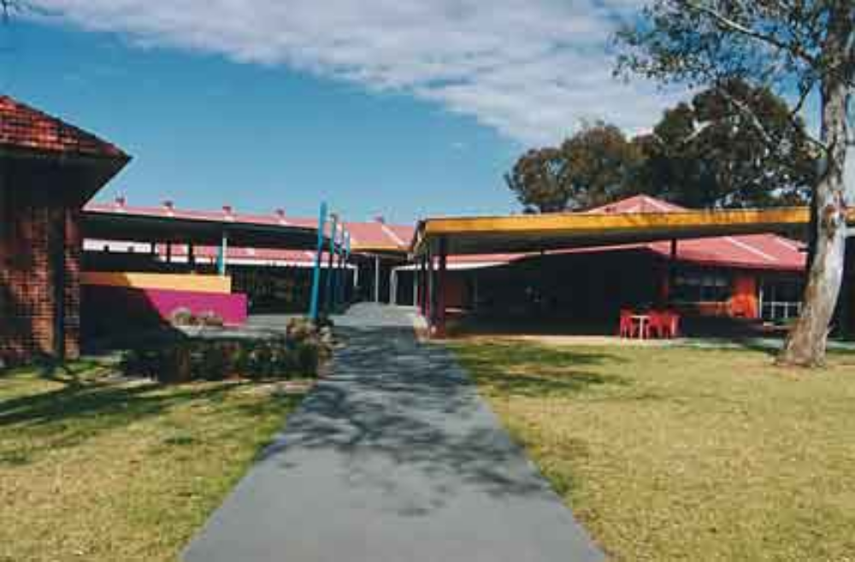
Suspension = No school
EDUPRO Behaviour Support Plan Guide (pre 2010)
Student: ` Date: (devised)
Problematic Behaviour:  Type & one specific behaviour  (observable, replicable, able to be counted) |  | Expected positive behaviour: skills to be learnt, the fair pair behaviour
Challenging Behaviour | Purpose of behaviour | Fair Pair | What to teach
Details: What, body position, where, who  E.g. Biting other students, hits head forward on hands, when leaning against hard surface | Determine this by using (see intranet): | The behaviour you want to teach  The positive alternative to the challenging behaviour e.g.  Running away→staying inside boundaries | Strategies/programs to teach positive behaviours  E.g. Social stories, rules, task analysis, photo timetable, relaxation, sills training
 | - ABC & frequency data  - Aide to Functional Analysis  - Motivational Assessment Scale Problem Behaviour Questionnaire | Matching the function of type of behaviour e.g. Sensory, escape/avoidance  Initiating social contact, obtaining objects/events, express emotion, reduce stress | Type of Prompt Hierarchy

Changes to environment (ecological) | Changes to IEP  (positive programming) | Changes to the IEP  (positive programming) | What do we do when…  (reactive strategies)

Changes to staffing, placement/role of staff  Signs  Changes to communication symbols/displayed carried  Changes to Boundaries  Equipment changes – student, class, whole school  Timetable changes – class, whole school | This matches the challenging behaviour e.g. Can’t wait, gets out of chair, and runs away from group. | Positive reinforcement: winks, touch to arm, stickers, privileges. Assembly awards, phasing out of prompting, cues, personnel. What behaviour positive reinforcement is for  How often | Consequences related to the behaviour – agreed before  Must be fair  Consistently applied across whole school environment & day  Must be able to be understood by student  Within rules of classroom & school. In accordance with School Discipline Policy  Crisis Support Plan
Positioning of equipment  Seating arrangements  Transport changes  PART training | Understanding/accepting “wait” symbol, gesture, frustration  Extending the period of time before the behaviour occurs again | Type of data collection: what, who, when  Who is collecting data | What to do now (Priorities: what, who, when)
Arrival/departure times/arrangements  Changes to student grouping  Use of communication symbol book between home and school  Supervision changes | Leaning to ask for “help”  Social stories for the problem behaviours  Prompt strategies | Skills to be taught – how, what, when, who  Any underpinning educational aims e.g.  Maximise learning time  Receptive/expressive language taught:  “finished:, symbols for activities, red cross card | Who is responsible for implementing the program  Practical issues – who is responsible for implementing which changes, communicating & documenting these  When to review; future plans  Coordinating discussion of changes at home
Risk Assessment format – see DEC OHS Directorate Crisis Management Plan See Individual student electronic folder To be used in conjunction with behaviour support plan


